**ASSIGNMENT 4**

**Scanning of Networks and Open Ports**

# **INDEX**

|  |  |  |
| --- | --- | --- |
| **SL NO** | **TOPIC** | **PAGE NO** |
| 1. | Scan on Home Network | 2-9 |
| 2. | Scan on Portswigger Application | 9 |
|  |  |  |

# **Topic: Scanning of Networks And Open Ports**

ASSIGNMENT 4(DAY 4) Date:30-06-2022

1. **Screenshot of detailed scan on Home Network.**

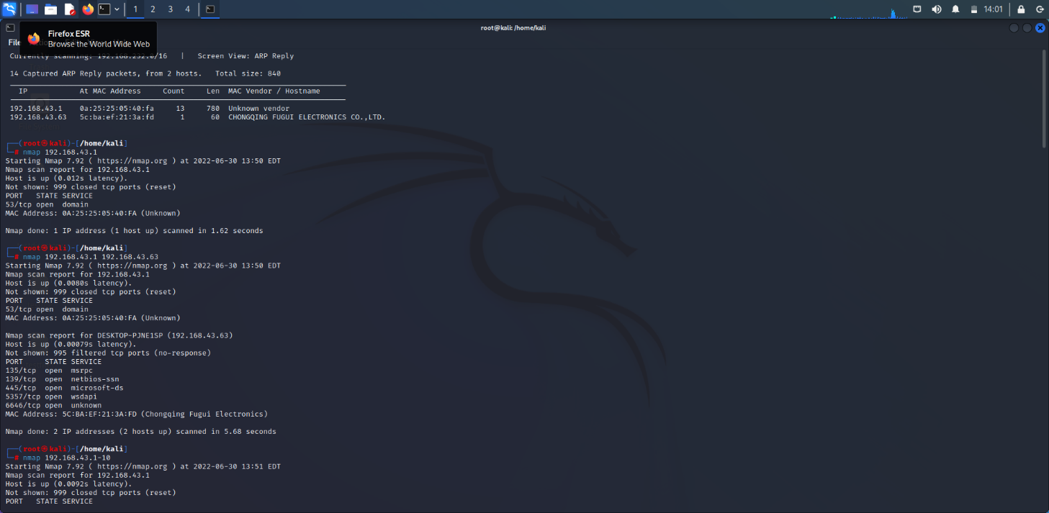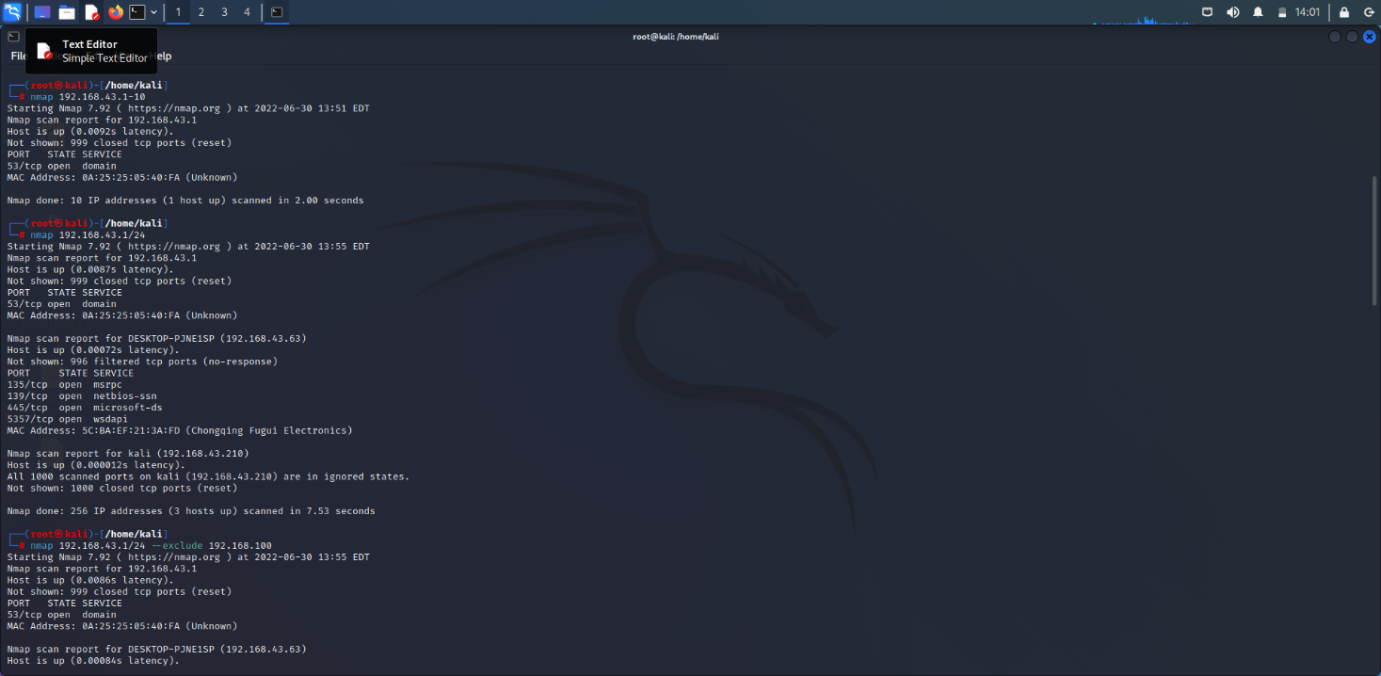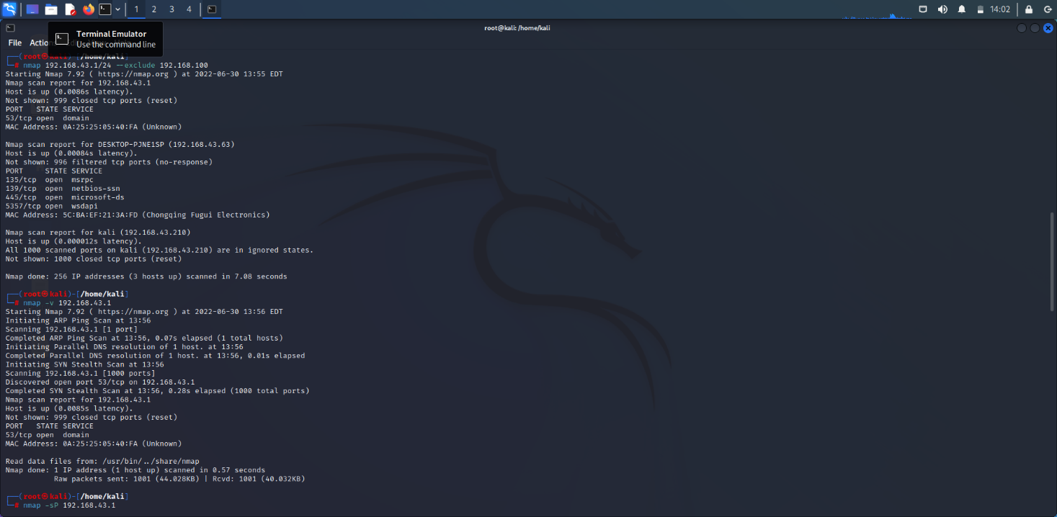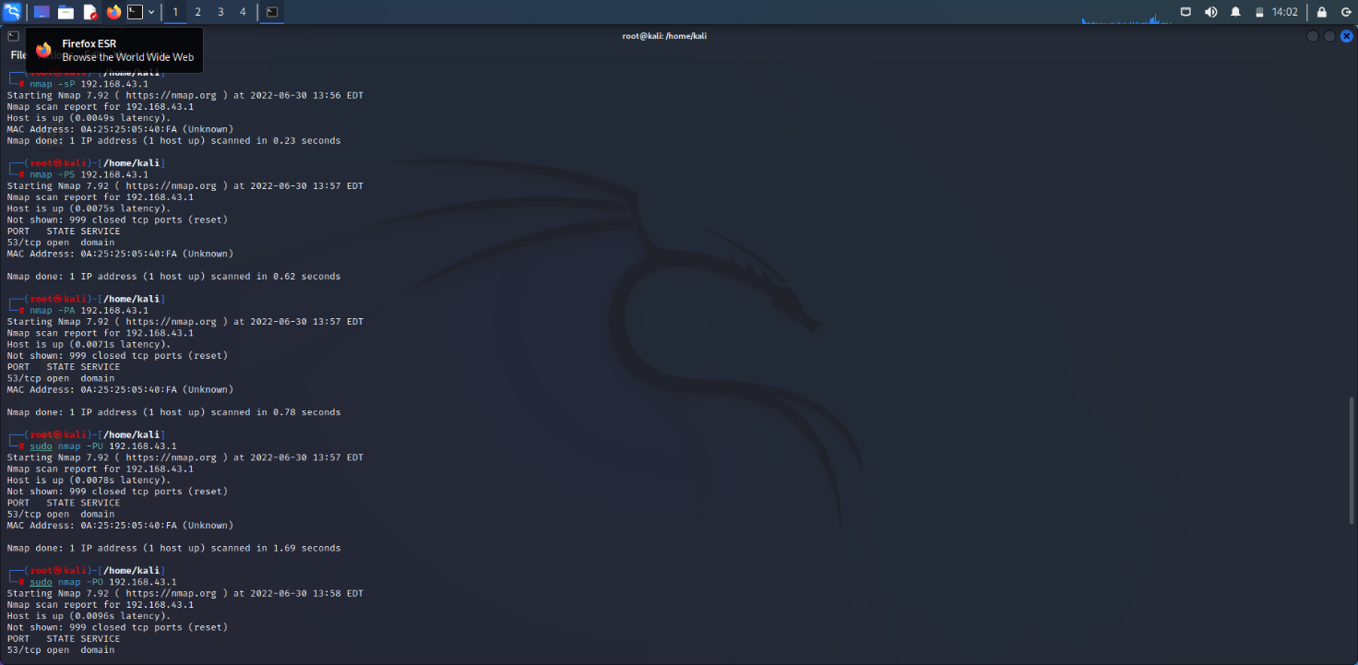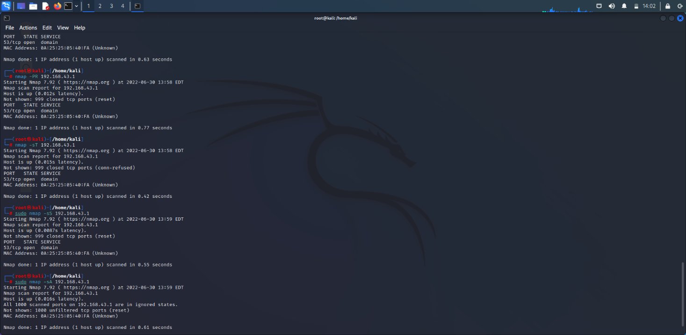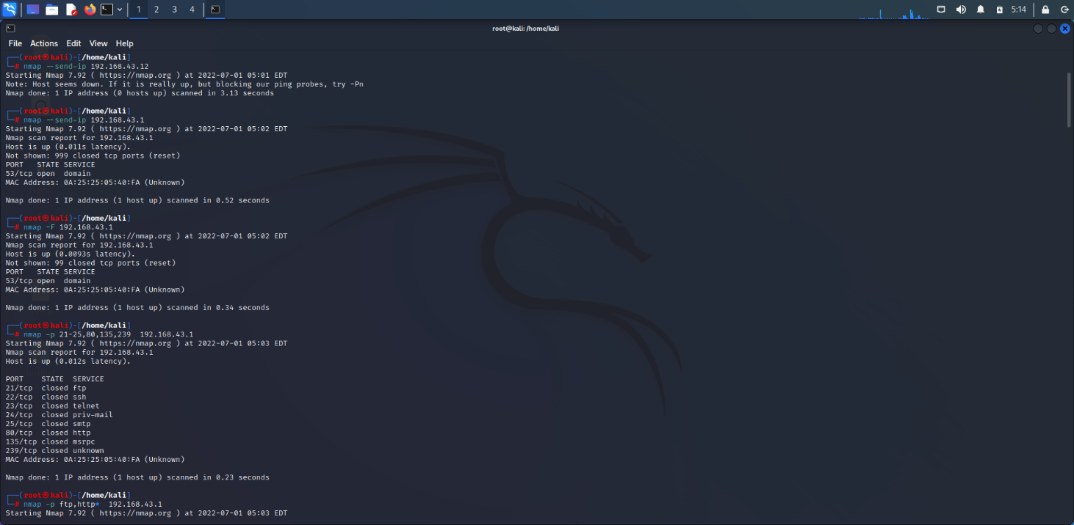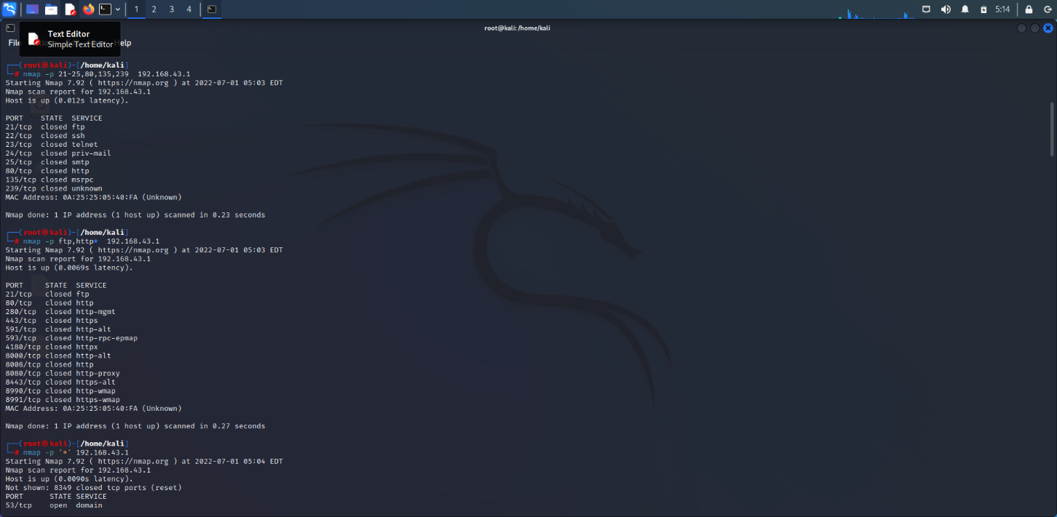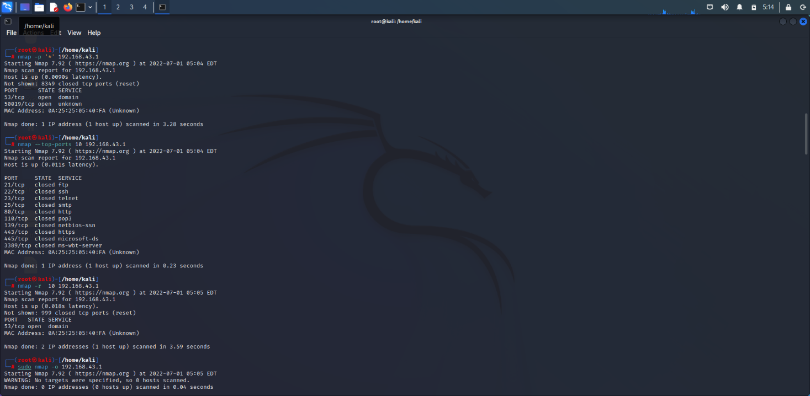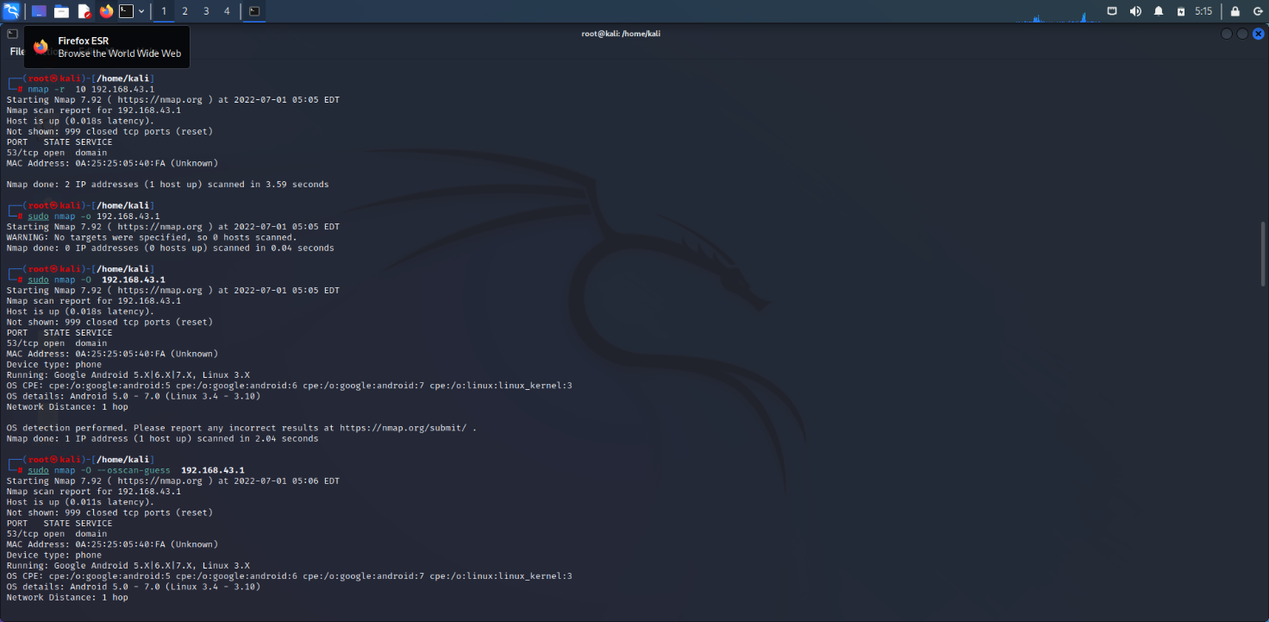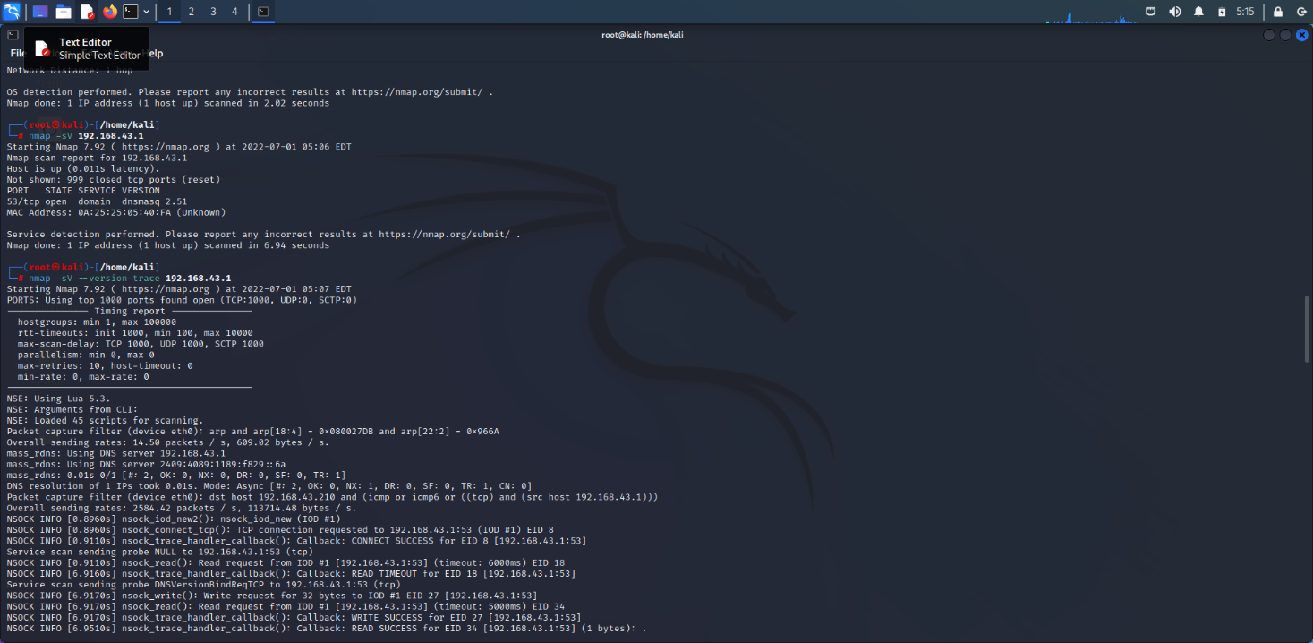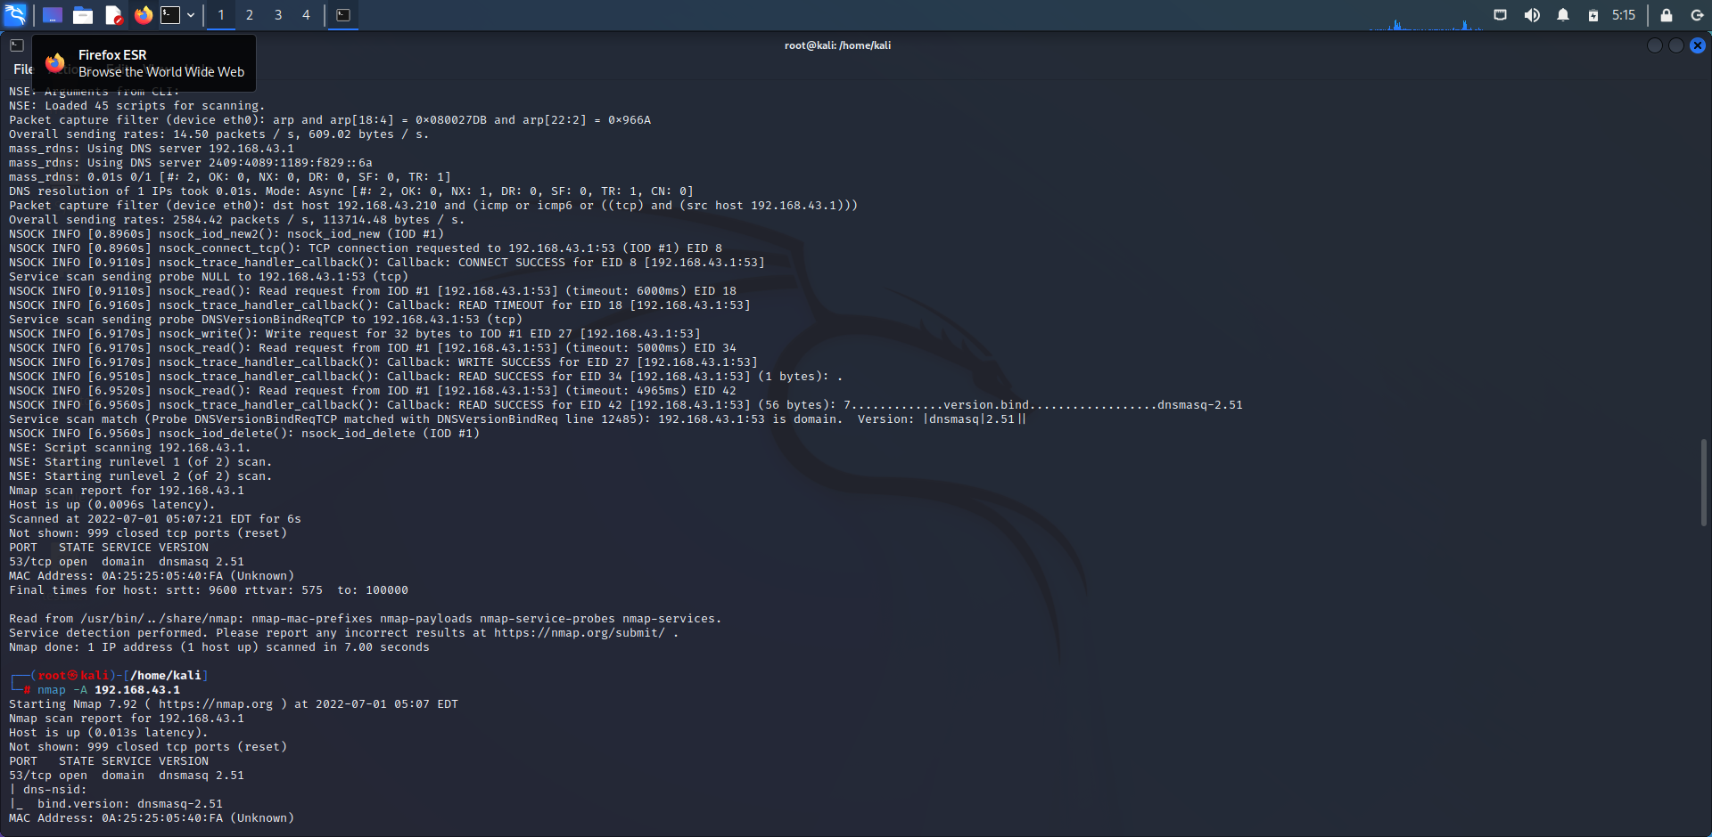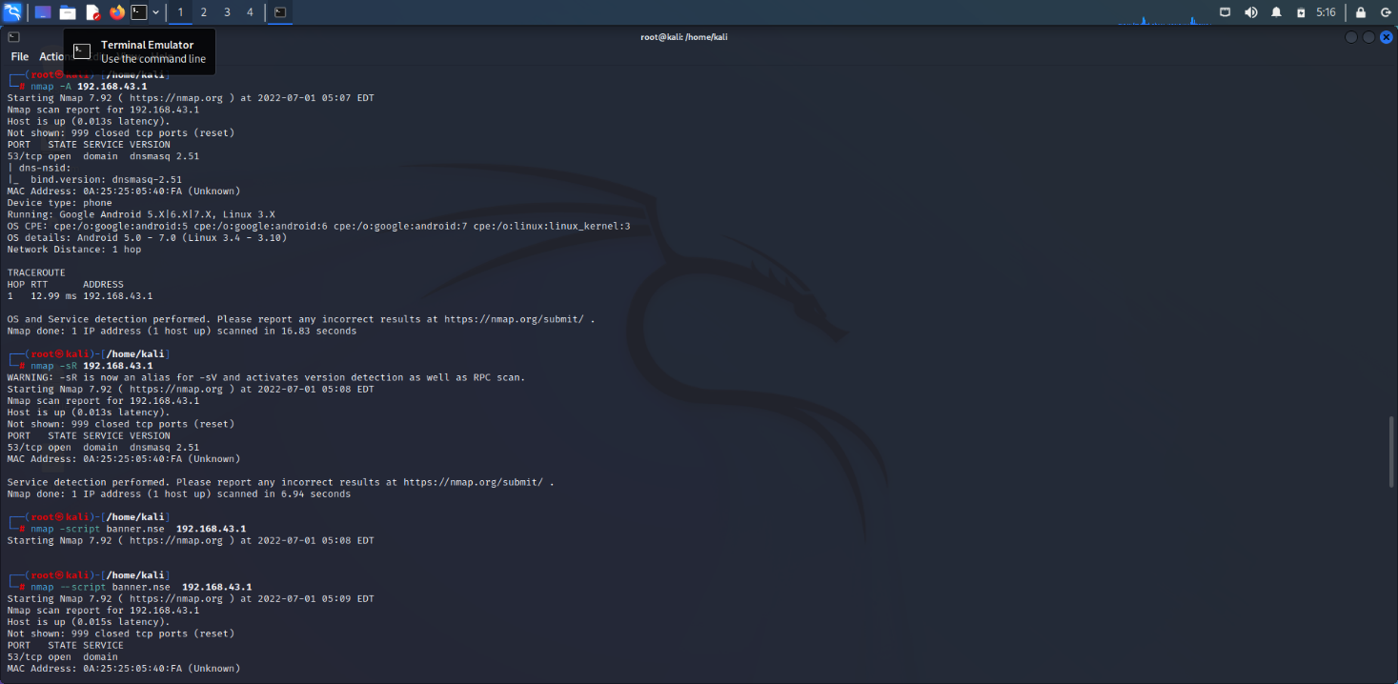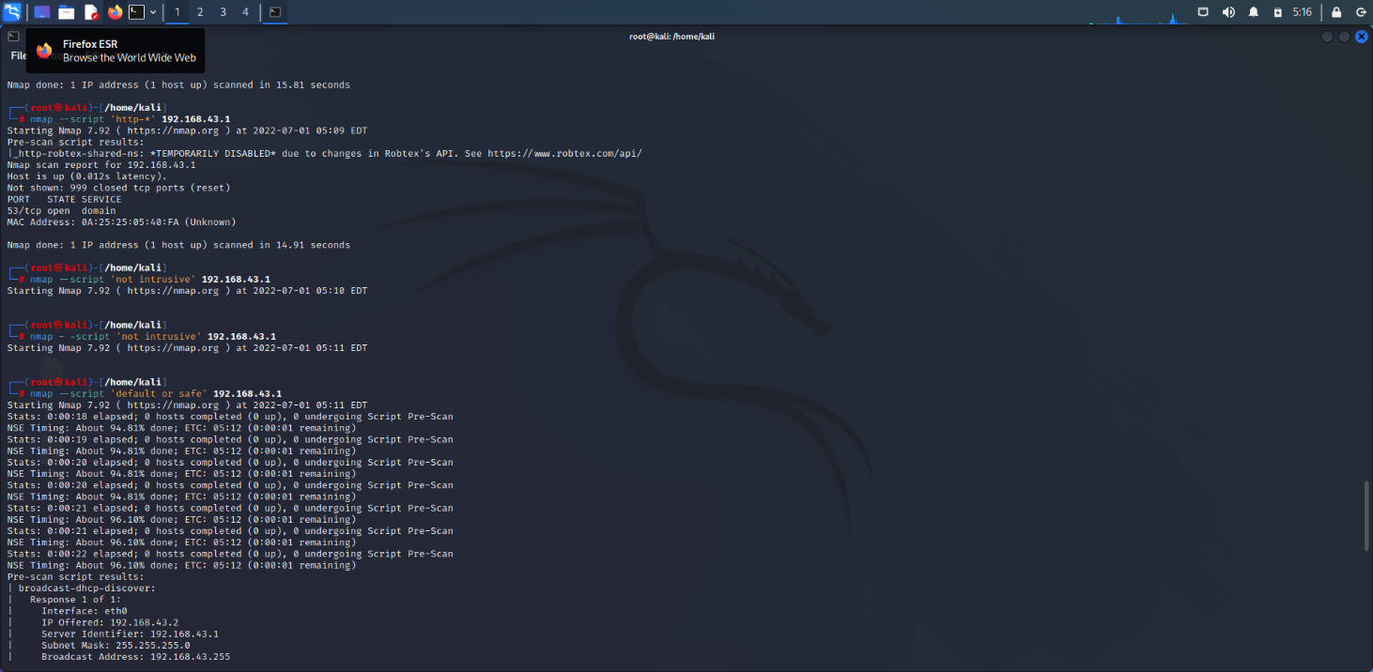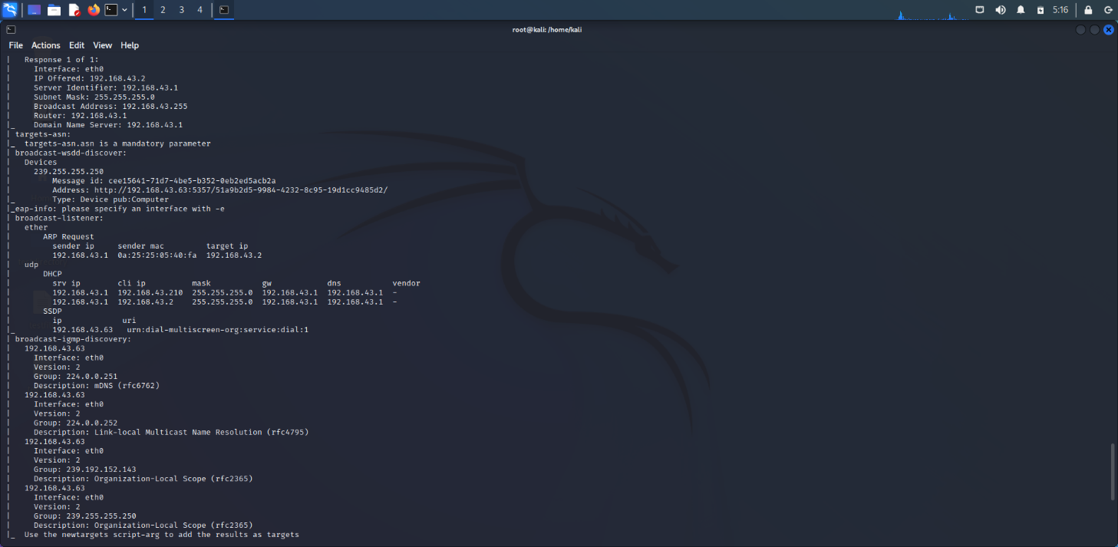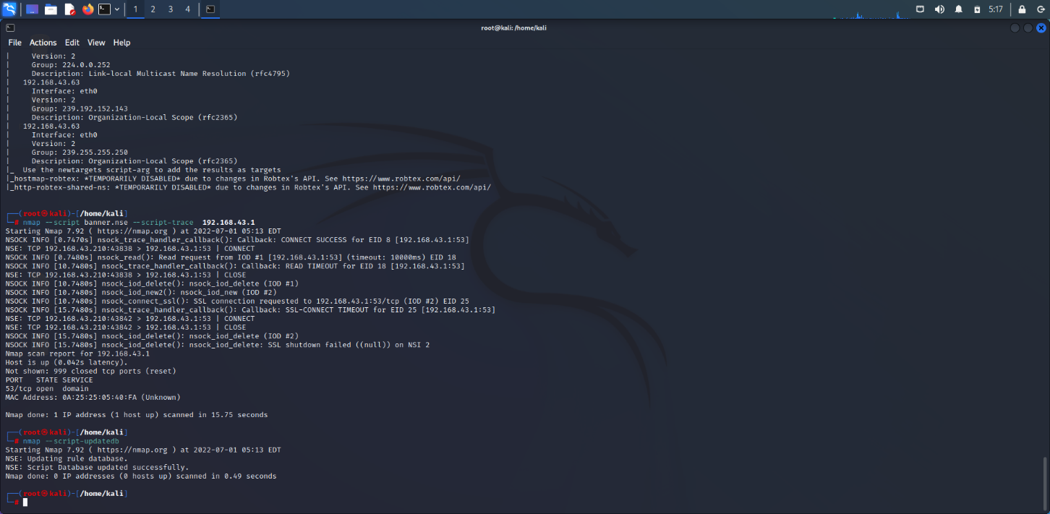

1. **Screenshot of Portswigger application.**

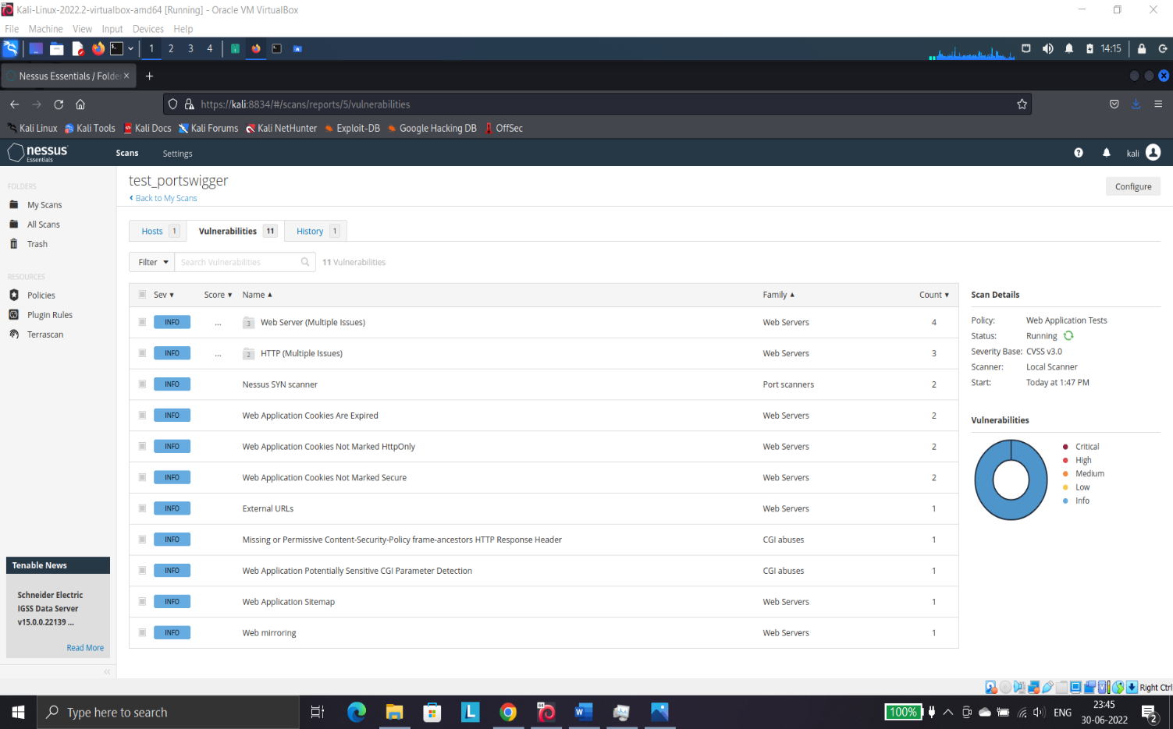

**Name: I PRASANTI**

**Sic: 20BCEA56**

**Branch: CEN**